WINDOWS

**Screenshot 1.**  18.223.252.254

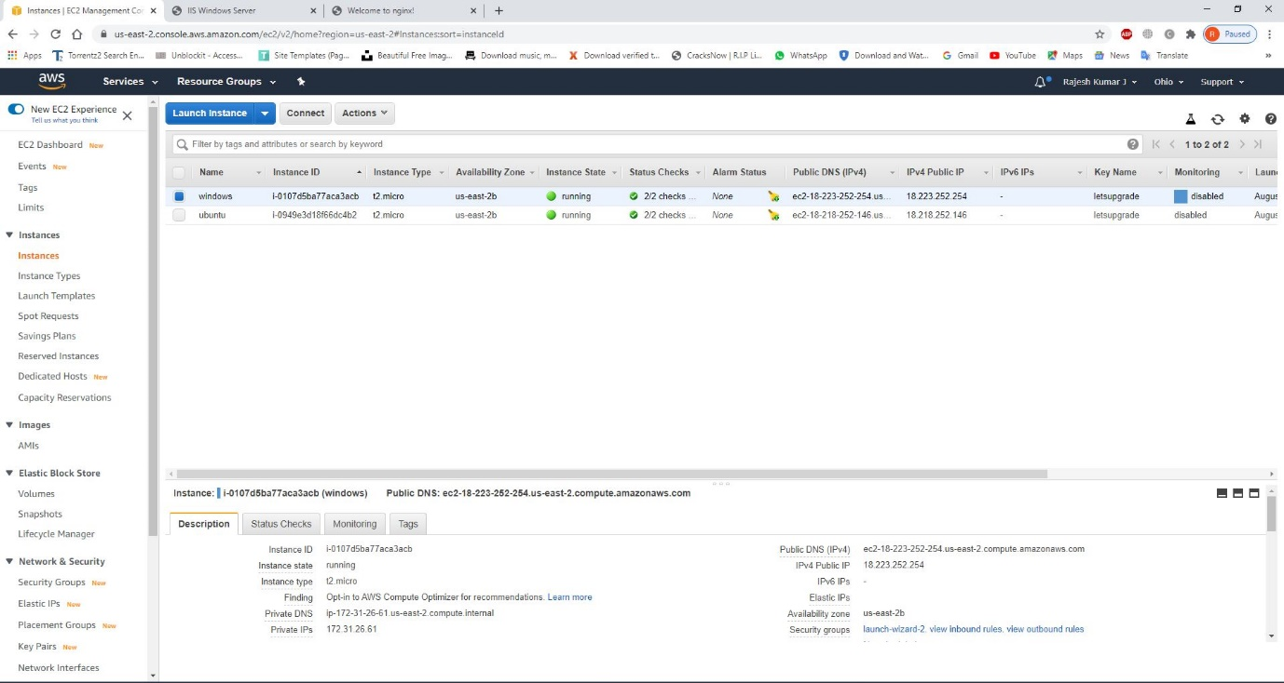

**Screenshot2.**  18.223.252.254

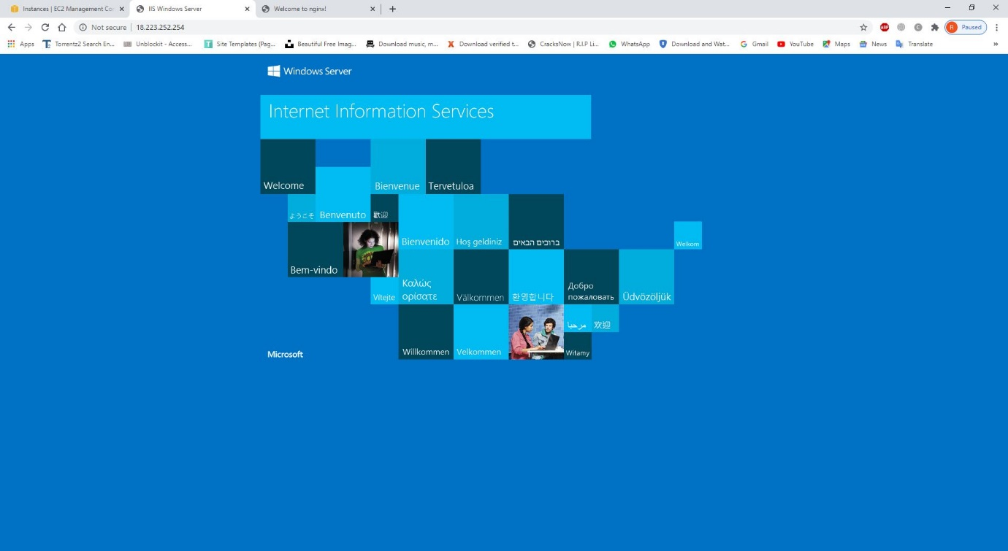

UBUNTU

**Screenshot1.**  18.218.252.146

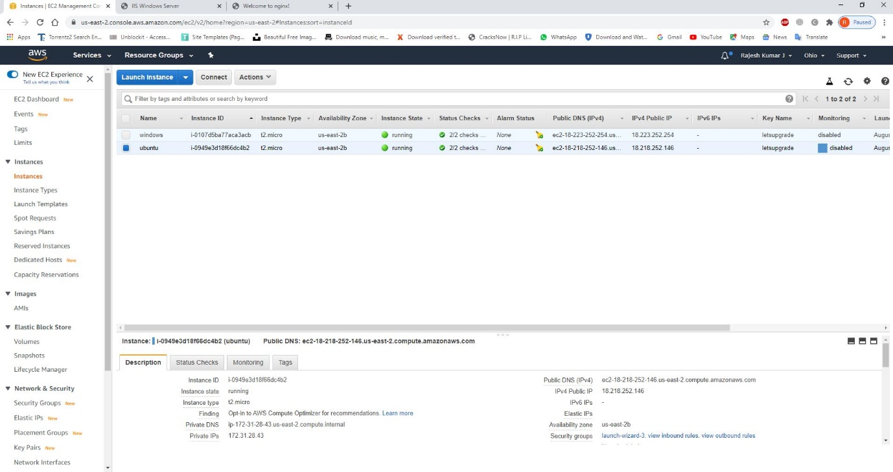

**Screenshot2.**  18.218.252.146

